**A Beginner's Guide to Azure Storage**

Azure provides various storage solutions to help businesses manage their data, whether you're storing simple files or managing virtual machine disks.

# Different Types of Azure Storage

Azure offers three main types of storage:

## 1. Azure Blobs

Azure Blob Storage is like a big container for storing all kinds of files, such as documents, images, and videos. It's perfect for storing large amounts of unstructured data.

## 2. Azure Files

Azure Files gives you a place in the cloud to store and share files. You can access these files just like you would on a regular network drive.

## 3. Azure Disks

Azure Disks are used as virtual hard drives for Azure Virtual Machines. They store data that needs to be kept even when the virtual machine is turned off.

# Key Differences

| **Azure Blobs** | **Azure Files** | **Azure Disks** |
| --- | --- | --- |
| Object Storage | File Storage | Disk Storage |
| Stores files in containers | Stores files in folders | Acts as a virtual hard drive |

## Types of Azure Storage Accounts

Azure storage comes in two main types of accounts: **Standard** and **Premium**.

## 1. Standard Account

This is the most common type, offering basic storage services like Containers, File Shares, Tables, and Queues. It’s great for general use.

## 2. Premium Account

Premium accounts are designed for higher performance needs. They support:

* **Page Blobs**: Used for operating systems or virtual machine disks.
* **Block Blobs**: High-performance file storage.
* **Append Blobs**: Ideal for storing logs or event data.
* **File Share**: High-performance file storage.

## Detailed Premium Account Types

| **Premium Account Type** | **Usage** |
| --- | --- |
| Page Blobs | Virtual Machine Disks |
| Block Blobs | High-Performance File Storage |
| Append Blobs | Logs and Events |
| File Share | High-Performance File Storage |

## Data Backup and Replication Options

Azure provides several ways to back up and replicate your data to keep it safe:

## Locally Redundant Storage (LRS)

* + Keeps three copies of your data in one data center.

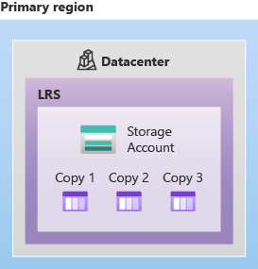

## Zone-Redundant Storage (ZRS)

* + Spreads your data across three zones in a region.

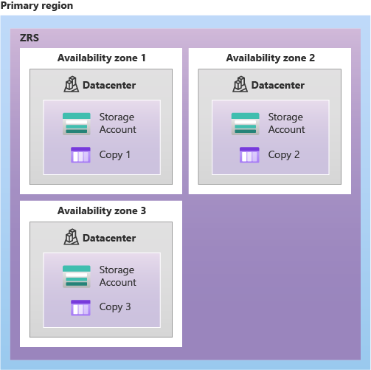

## Geo-Redundant Storage (GRS)

* + Copies your data to another region, protecting it even if one region fails.

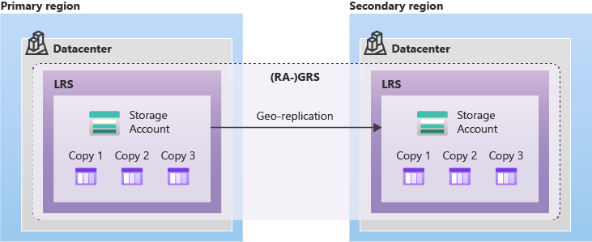

## Read-Access Geo-Redundant Storage (RA-GRS)

* + Lets you read data from the backup region, ensuring high availability.



## Read-Access Geo-Zone-Redundant Storage (RA-GZRS)

* + Combines the benefits of ZRS and GRS, offering high durability across zones and regions.

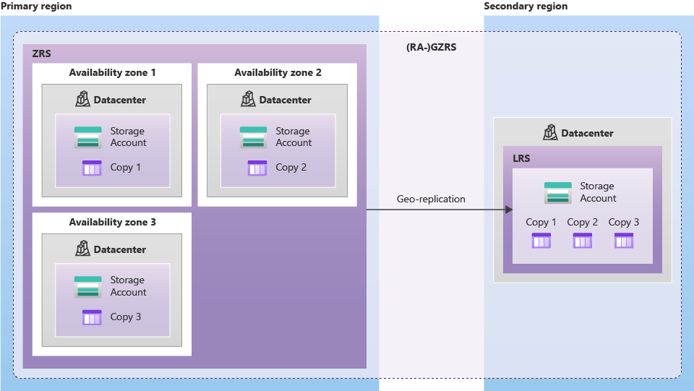

## **Choosing the Right Storage Option**

When choosing a storage solution in Azure, consider both performance and how your data is backed up:

| **Performance** | **Account Type** | **Replication** |
| --- | --- | --- |
| Standard | Basic storage | LRS, ZRS, GRS |
| Premium | High-performance storage | LRS, ZRS |

## Things to Remember:

* **Standard Accounts**: You can change the replication type (LRS, ZRS, GRS) after creation, but you can't change the performance type.
* **Premium Accounts**: You can't change the replication or performance types after creating the account.